In this documentation for Big Mountain ski resort we were able to identify ideal price based on a number of driving criteria as listed vertical drop, snow making equipment, number of chairs, fast quads, runs, longest run and trams. To do this we mapped our company’s position on these key price drivers against industry standard in relation to price and found that Big Mountain was on par or higher than most competitors across the board and as such indicate a higher value to customer and can request a higher ticket price.

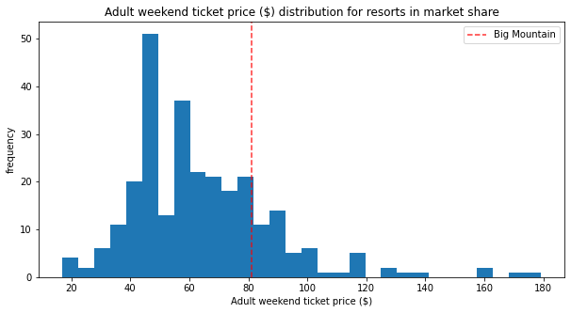 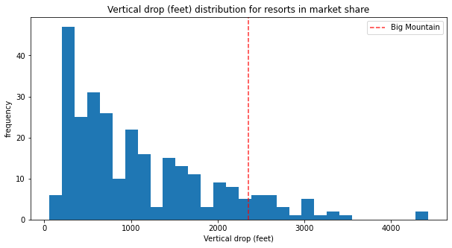

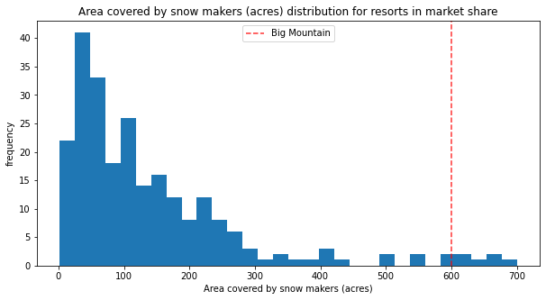 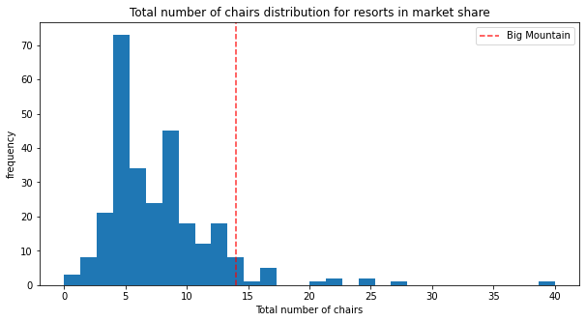

We utilized a random forest regression model to identify the best practice to fill for missing comparative data and through this we were able to identify the price value of key values and indicatre that the true best practice price when factoring in value would be a price of $95.85 with a mean absolute error of 10.39 meaning at our lowest price we should fall at $85.48 and our highest acceptable price should fall around $106.26.

These assumptions however are driven by prices generated at other resorts and opens up the risk that resorts may be over or under priced as such modeling was done to present cost saving features and impact on expected ticket price. The following looks to identify ticket price and revenue based on number of runs closed based on industry standard pricing in relationship to number of runs

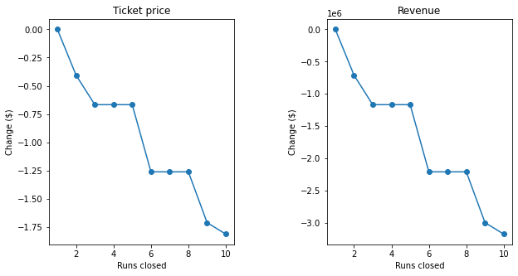

As such the data indicates in all ways that Big Mountain is justified in a price increase from as little as a $4 increase to as much as a $25 based on current position.